Photo report wi_8_f_2500_ Tripp 2 2015 Angola HPW
Photo Report 07:06. / 06.23.2015 "Hans-Peter Widmer"

 | Table of Contents:
1 | Mega Bore repair gear |  |  |  | Page | 1-4
2 | Gurutzpe water damage |  |  |  | Page | 5
3 | Knuth Shears |  |  |  | Page | 5 - 6
4 | Schäublin Milling machine |  |  |  | Page | 6
5 | Niles Conv. Lathe |  |  |  | Page | 6 - 7
6 | Storebro konv.Drehbank |  |  |  | Page | 7
7 | Oxy Cut Machine |  |  |  | Page | 8
8 | Does He Know |  |  |  | Page | 8-
9 | Mas radial drilling machine |  |  |  | Page | 9-10
10 | Deep hole drilling machine TBT |  |  |  | Page | 10
11 | Farr Torq |  |  |  | Page | 11
12 | Gornati CNC Lathe |  |  |  | Page | 11 - 12
13 | Facum Lifter |  |  |  | Page | 12 - 13
14 | Yellow boxes |  |  |  | Page | 14 - 15
15 | Medication |  |  |  | Page | 15 | Page | 11
16 | Tool bags Angola |  |  |  | Page | 15-16

- Mega Bore CNC lathe

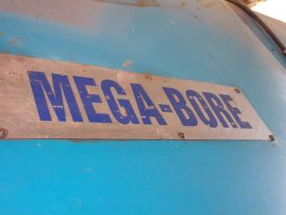
P1: The CNC Lathe Bore Mega strike again. Transmission does not go.

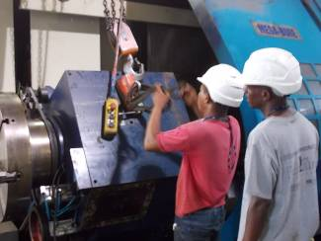
P2. The cover has to be lifted

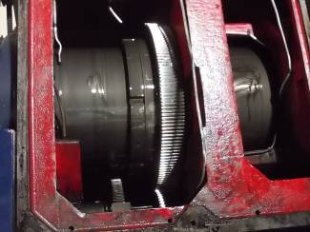
P3. Everything inside is studded with a dark lining. It is an abrasion.
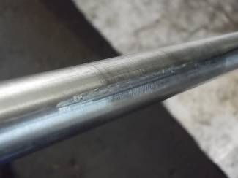
P4. A shaft on which the shift fork runs, has eroded. Unfortunately, the material pairing steel on steel was chosen. It gives only a friction of 0.01 with n oil. But there are no lubrication holes. So there is a risk to eat. If brass or PTFE bushing in there, it would also not dry can chew.

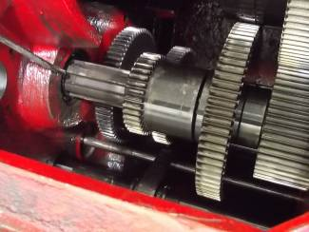
Mounted gear again: P5

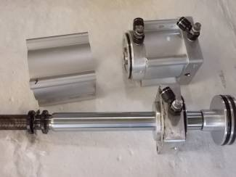
P6: The two cylinders that move the shift forks

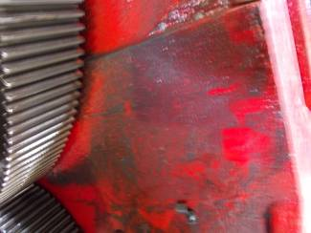
P7: The dirt abrasion

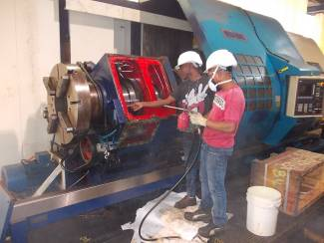
P8: The transmission was washed out

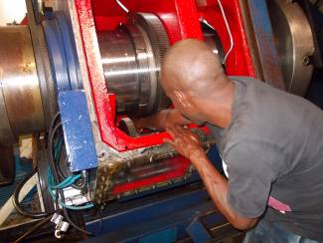
P9: Below, under the oil, is a flow filter. Only accessible with a very long arm.
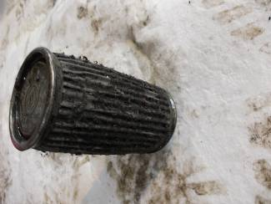
P10: Why the abrasion because in it, we did not recognize.

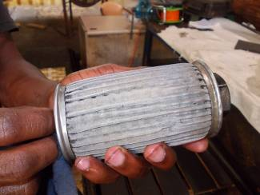
P11: The cleaned filter

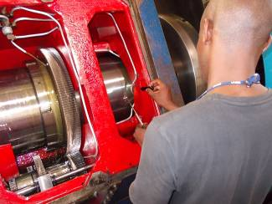
P12: Now the gear again looks nice. The filter system has to be also grown.

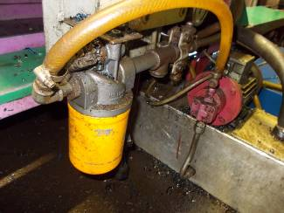
P13: At the Gornati: With all CNC machines of the WIAP, it has 10 micron filter. Outside with a signal switch, so that the dirt in the oil can be intercepted. Each gear of the machine with the filters, can after 10 years of gearbox cover
be lifted. It does not have any traces of dirt.

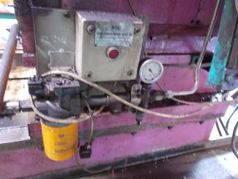
P14: At the Gurutzspe

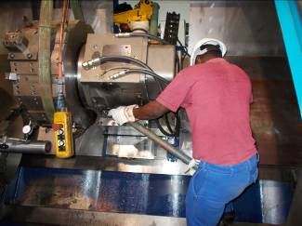
P15: The turret of the Mega Bore was inclined to 100 mm travel 1 mm. So again a big crash.

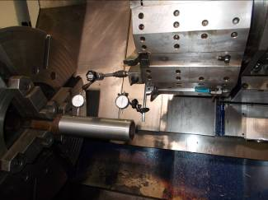
P16: The headstock was 300 mm 0:17 mm diagonally. Very complex align the headstock at a slant bed lathe.

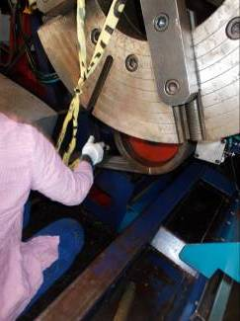
P17: detach the headstock is very difficult. These M24 bolts grade 12.9 must be tightened and loosened on one meter by 94 kg. That takes a lot of force.

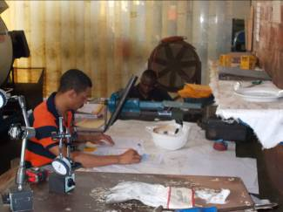
P18: Carlos must now fill in for the VAM audit next Monday the protocols. The exact work has paid off. For the maintenance of Algoa got VAM
100% rating.

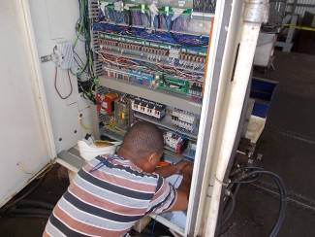
P19: at the Mega Bore we also have the TCC, Tropical Cabine Controll installed.

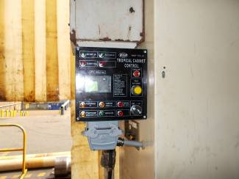
P20: The TCC during the cultivation.

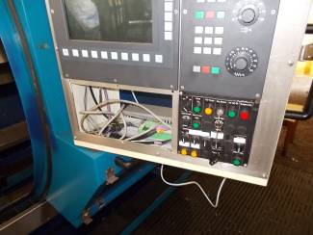
P21: Yet another keyboard at the Gurutzpe is defective. It always freezes the CNC a. The letter S cheated.

. 2 Gurutzpe CNC Lathe

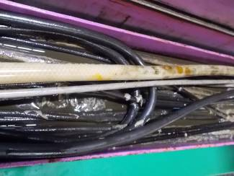
P22: A water hose rupture in the energy supply was a big mess.

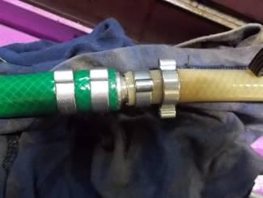
P23: A new clutch rotated and attached double hose clamps

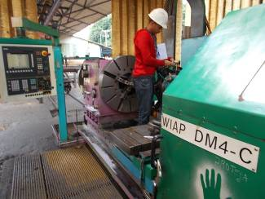

P24: Always the end of June to be replaced on all CNC lathes the documents. The geometry test renewed, which has to be made each year.

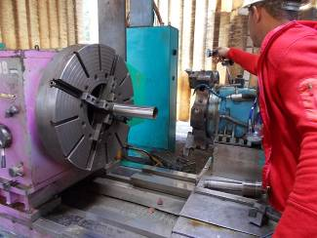
P25: The conicity of the workpiece the headstock is calculated. 7 pages protocol for VAM. 14 pages has the internal protocol.

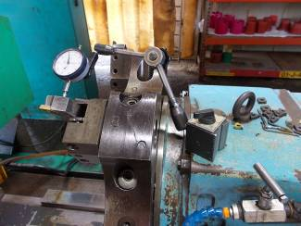
P26: The turret must be without play, otherwise it will vibrate during rotation. This means that the quality requirements are not met.

. 3 Knuth Shears 20mm Top Hill

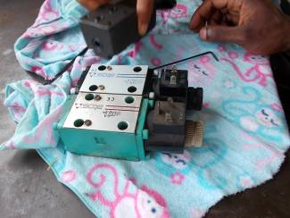
P29: The machine does not move. The valve was replaced. That was not the problem.

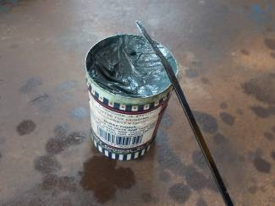
P30: With lapping paste the clamping slide has yet been made accessible. This has to be cleaned very well again. Not the residue then lapping.

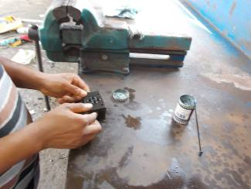
P31: lapping valve

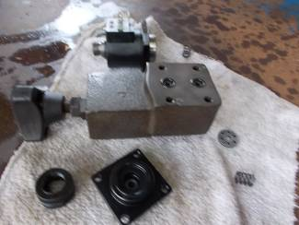
P32: The pressure controller was in the purification. It was then a slide in the hydraulic block jammed.

4. Schäublin Conv. Lathe

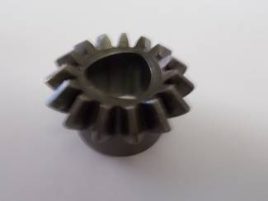
P33: For a polygon gear was broken. It had to be found in Europe. Offer received for the spare tire

5. Niles lathe

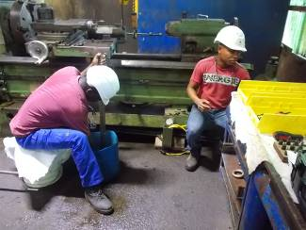
P34: A gear is broken in the Niles lathe

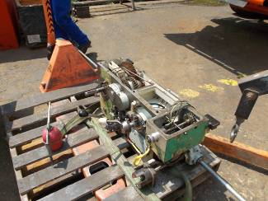
P35: The gearbox had to be dismantled and taken apart.

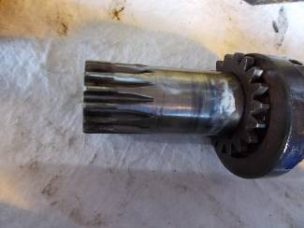
P36: The defective wheel in the feed gear

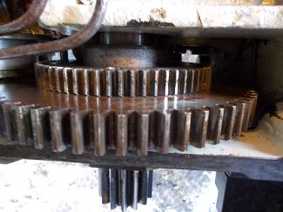
P37: The defective wheel, the smaller, the more teeth are broken. Was welded and repaired. Unfortunately not good enough. The old module was chosen wrong because the break anything so deformed that it could not be determined correctly. When the gear was worn with the dividing head, teeth ware once with too little, then again with too great a distance.

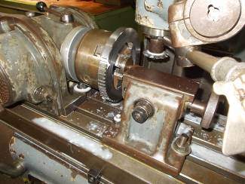
P38: the large gear is re-established. Unfortunately, with the module 2.5 mills, instead of the 2 module cutters. Here we have to gear training with the machine people. They do not know that the diameter divided by the number of teeth, +2 teeth, the module outputs.

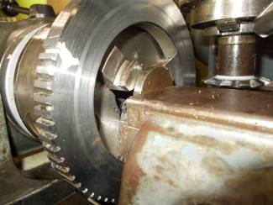
P39: Nevertheless gears can be made in Angola.

6. Storebro Conv. Lathe

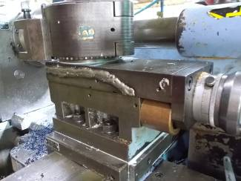
P40: At the Storebro 260 GS the top slide is broken. Make a new one. Organize cast iron.

. 7 Oxy Cut Machine

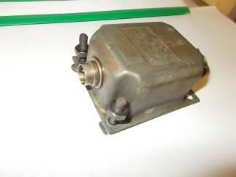
P41: For Oxycut the igniter is defective. New sought. Offer available for order.

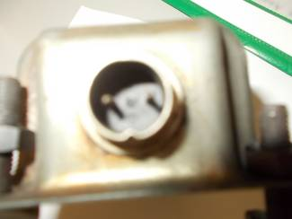
P42: plug the ignitor

8. Weisser CNC Lathe

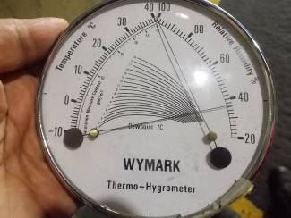
P43: For the Weisser CNC lathe we needed the thermometer, which we had forgotten in the closet of Gurutzpe. Just 40 degrees Chill and humidity below 40%. All right. Ev. Aircon still install and cool to 32 degrees down. Not deep, otherwise there is condensation.

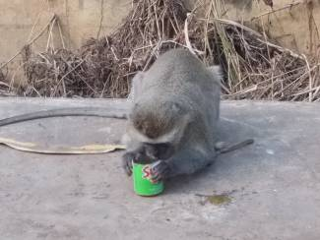
P44: Monkeys can also drink out of the can!

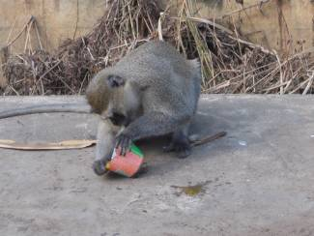
P45: So when machines are in Africa next to the forest. There are also monkeys there.

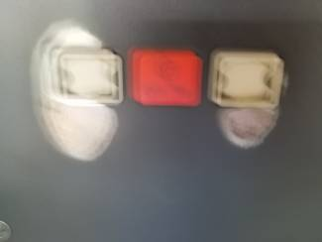
P46: Almost all CNC machines the reset button and the Start button looks totally worn out! These keys we need to organize.

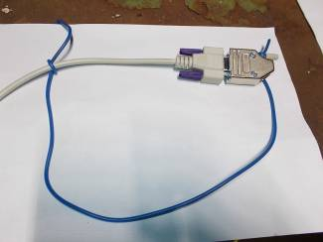
P47: If open plug in Angola remain open for several days, they oxidize and the signal transmission is no longer good. That is why we now have a dummy plug system as a temporary solution until we have a DNC system chosen.

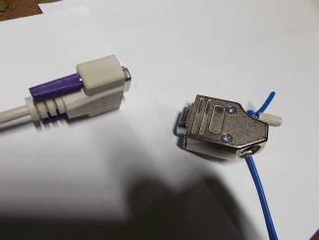
P48: Inlet Protection. But tie everything in Angola, which is quickly gone.

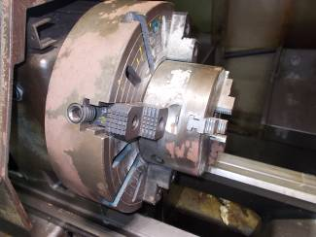
P49: The rust, the permanent enemy

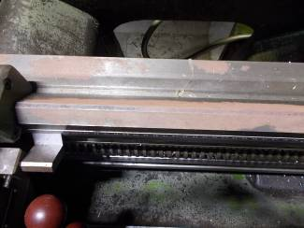
P50 Short look away and everything is rusty. The surgeons always think the maintenance is responsible. They themselves are too lazy. It's too much work and the machinery maintenance has too few people.

9. MAS radial drilling machine Top Hill

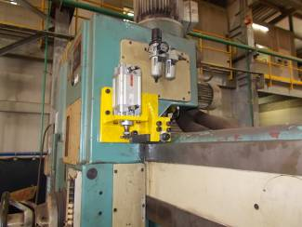
P51: At this drill is a brake outside in cultivation. The original brake is inside. Several times a disassembly was required. Since everything had to be dismantled. Always stop for about 3 days. Now peace will be.

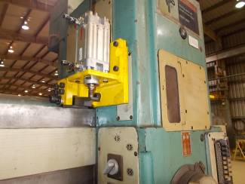
P52: The brake clamped via a lever with 1,200 kp x2.

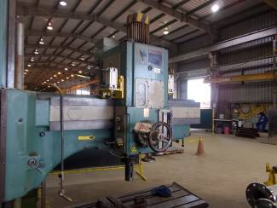
P53: both sides brake 600 each (3 bar) to 1200, 6 bar kp

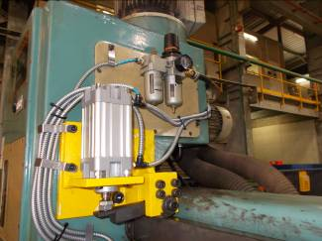
X54: The lines were protected against chips. Such protection hose, we also need to take in the order list. We still had a few feet in the camp.

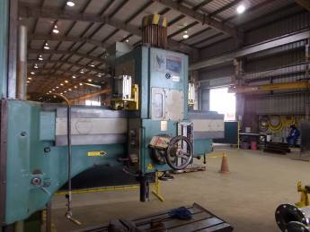

P55: New brake system constructed; Outside mounted.

10. TBT deep hole drilling machine TIBO

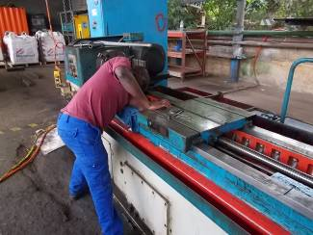
P60: The deep hole drilling machine "TBT TIBO" lost per day several liters of hydraulic oil in the working oil. It had to be dismantled 2 sled. Doing some maintenance work could also be made equal.

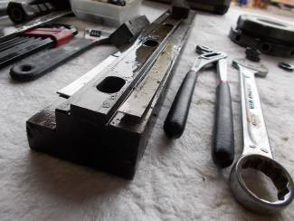
P61: The company has instead milled and scraped, backed only board lessons as distance. Unusual for a mechanical engineer. Normal is milling and scraping usual.

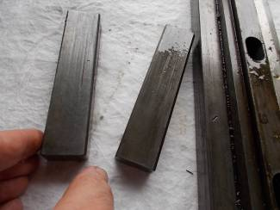
P62: The contact grips are not scraped, just milled.

11. Farr Torq engine

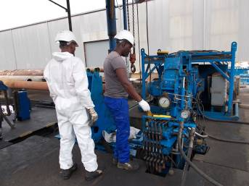
P66: Right, the new maintenance man. His name is Kim. He joins us. Has good intuition when Farr machine. To watch knows exactly and without which lever for what.

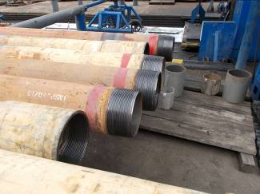
P67: New series are produced at the Farr machine. It can not be that every 15 minutes must go man aufzunehem a protocol. New pipes are all prepared, all consecutively recorded in a train with the computer.

12. Goranti WIAP CNC Lathe

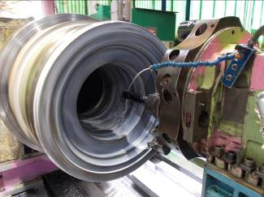
P68: A P1 job came in where had to work at night.

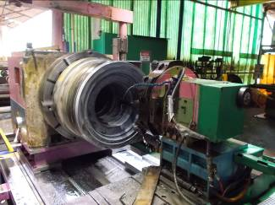
P69: The workpiece on the Gornati is difficult. Fortunately the machine bed is wide and stable. The feed force good enough.

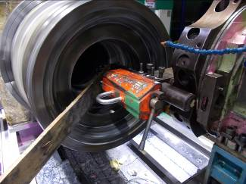
P: Unfortunately, too few steels are available in order to turn vibration free can. It had to improvise something.

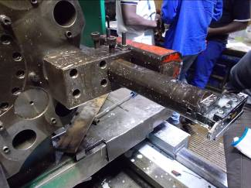
P70: to make a Innnedrehstahl of an outer turning tool, was complicated because the geometry had to be adapted. In other words, an outer steel has a different clearance angle than an inner steel.

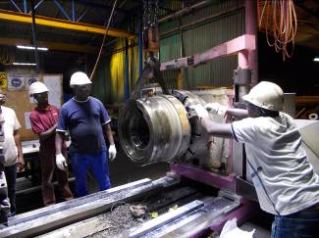
P57: Finally, the workpiece 1 is completed. Now even comes the second.

13. Vacum Lifter

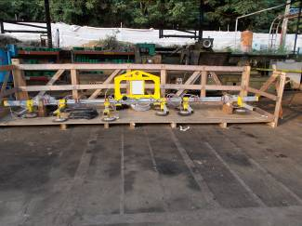
P58: Vacum Heber. Who was appointed for the waterjet machine, because there's a lot of stainless material.

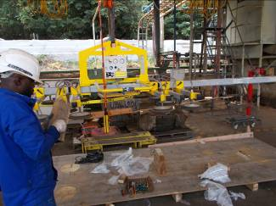
P59: He should lift plates up to 50 mm thickness and 2600 x 1300 mm

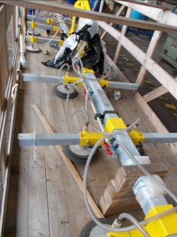
P60: The transport box was damaged. The manufacturer has not much considered when installing the package.

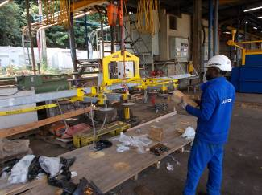
P61: The wooden floor is broken through. The suction cups standing on the ground. That was not the goal of the package.
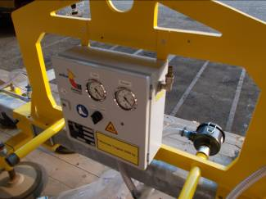
P62: Control of the intake system

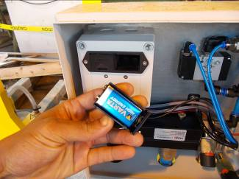
P63: A battery unterstüztes system. 2 batteries

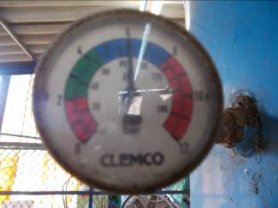

P64: Before starting a test system, if the system pressure corresponds to the pressure.
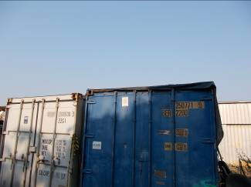
P65: A variant where the Vacum lifting device could be cleared away. On the two containers. But is frowned by Chevron.

13 .Schubladen Angola

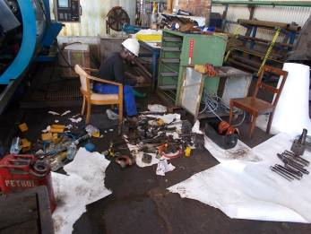

P66: The shock! These drawers we cleaned up a few months ago. And again as a mess ?! Angola has a problem with drawers

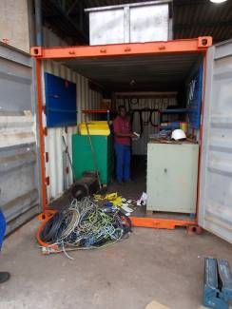
P67: Alberto has been around for 2 years to clean up the program container. He now thought possibly it's better he does it before I come up with the idea, because once again to look in!

14 Yellow boxes

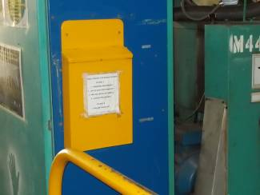
P68: This yellow boxes could tell stories. Since about 2008 applications.
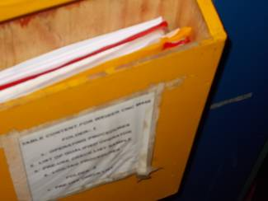

P69: Short Manual. Service Instructions, etc. A good thing. The machine mailbox.

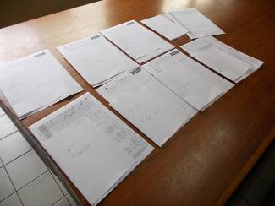
P70: Always the end of June each year, all the documents of the machine to be replaced. Renewed. The old stored in a folder for the auditors who always come and ask for it.

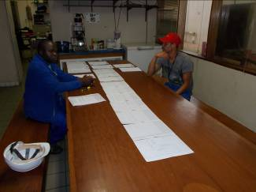P71: Here is the new documents will hergerichet for July 2015-June 2016

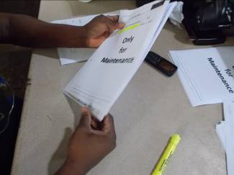
P72: Many papers every year.
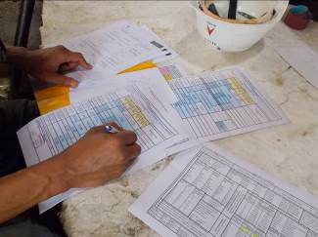
P73: For Vam the logs are filled

15 medicines in Angola

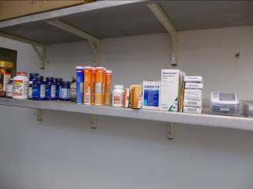
P74: The medicines and vitamins in the office to help with some things. Often people come and ask for a tablet for pain.


P75: Vitamins and minerals help in 70%

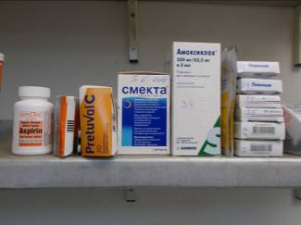
P76: Antibiotic collection. We could give to short before the hospital, so that Carlos wife had not flown to Namibia.

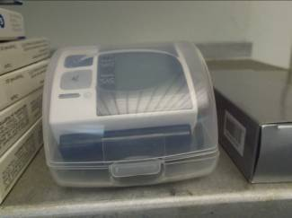
P77: A sphygmomanometer belongs in our pharmacy

16 Toolbox Algoa

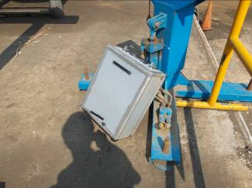
P78: Tool box. Alberto here with a new toolbox. Since 2 weeks in use. Exactly 2 weeks now, then he has fallen apart. No good quality tool. No good quality tool case. Those who work every day with tools, requires good tool.

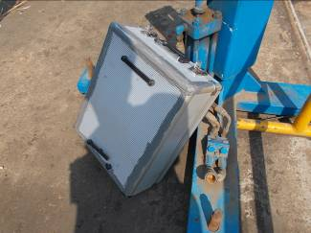
P79: Alberto had to stick everything.

End report H.P Widmer 07062015_23062915

